Rotella Chiropractic & Acupuncture Center

**Patient Information**

*Thank you for choosing our practice for your Chiropractic, Acupuncture, herbal and nutritional needs. Please complete this form. Please note that information provided on this form is confidential. It is very important the information given are complete and accurate to assist you properly in your healing process. If you have any questions or concerns, do not hesitate to ask for assistance.*

(Please Print)

Name _________________________________ Date_____________

First MI Last

Address ______________________________City______________State_______Zip________

Sex: __Female __Male ___Transgender/Intersex __Other

Birth Date ________________

Home Phone ________________ Cell Phone ___________ Work Phone_____________

Do you prefer to receive calls at: __Home __Work ___ Cell ___Doesn’t matter

Is it ok to leave a message? _____yes ____no

Email address____________________________________________________

Is it ok to send newsletter via email _____ Is it ok to send appointment reminders _______

Are you: __Minor __Married __Divorced __Widowed __Single __Separated ___Partnered

Occupation________________________

For minor’s only - parent’s name ________________

How did you hear about us?_____________________________________________________

Person to contact in case of emergency ________________________Phone ______________

**Patient Condition**

Reason for visit ______________________________________________________________

When did you first notice the symptoms?__________________________________________

Is this condition getting progressively worse? ______________________________________

Where is the problem located?__________________________________________________



Please list all medications, vitamins and herbs you are currently taking: ________________________________________________________________________________________________________________________________________________

Allergies: _____________________________________________________________________

Do you have any of the following? **Cold sores, ringworm, bed bugs, open wounds, scabies, boils, fungal infections, lice, mites, warts, impetigo, erysipelas, shingles, HIV, Hepatitis, poison ivy, or any contagious conditions?**  Yes___ No____ If yes, please describe______________________________________________________

Mark the diagram with pain and type of pain:

A – ACHE B – BURNING N – NUMBNESS P – PINS & NEEDLES S – STABBING O – OTHER.

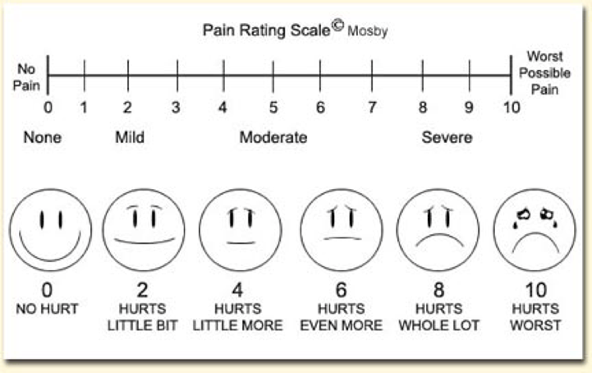

**Rate the severity of your pain from 0 to 10**

Please mark any of the following conditions or symptoms that you currently have:

Other Symptoms:_______________________________________________________

__ Headaches __ Pain in Hands or Arms __ Chest Pains

__ Neck Pain __ Numbness in Hands or Arms __ Heart Attack

__ Sleeping Problems __ Pain in Legs or Feet __ High Blood Pressure

__ Low Back Pain __ Numbness in Legs or Feet __ Stroke

__ Nervousness __ Fatigue __ Cancer

__ Tension __ Depression __ Painful Urination

__ Irritability __ Lights Bother Eyes __ Diabetes

__ Dizziness __ Loss of Memory __ Diarrhea

__ Pain Between Shoulders __ Shoulder Pain __ Constipation

__ Neck Stiff __ Sinus __ Stomach Upset

__ Joint Swelling __ Shortness of Breath __ Heartburn/Reflux

__ Fever __ Asthma __ Weight Loss

__ Loss of Balance __ Allergies __ Loss of Smell or Taste

__ Ringing in Ears __ Cold Hands __ Menstrual Cramps

__ Jaw/TMJ Problems __ Cold Feet __ Menopause

Please describe your history of conditions (such as Cardiac problems, Cancer, etc..) __________________________________________________________________________________________________________________________________________________________________________________________________________________________________________________________________

Date of last physical exam _________

Are you pregnant (Y/N Taking Birth control pills Y/N

**Cancelation policy**

*We understand that there are times when you must miss an appointment due to emergencies or obligations for work or family. However, when you do not call to cancel an appointment, you may be preventing another patient from getting much needed treatment. Conversely, the situation may arise where another patient fails to cancel and we are unable to schedule you for a visit, due to a seemingly “full” appointment book.*

*Patient, who fail to show for their scheduled appointment, or did not notify the office within 48 hours of their scheduled appointment time, shall be subject to a “No Show/Cancellation” fee of $50. Individual circumstances may be given exception.*

**Authorization**

*I certify that I have read and understand the above information to the best of my knowledge. I understand that providing incorrect information can be dangerous. I agree to be responsible for payment of all services rendered on my behalf or that of my dependents. I will be responsible for any outstanding sums due to this office, including interest, penalties, cancellation fees, return check fees, and all collection fees. I am aware that I will be responsible for additional fees for returned checks and that these fees may be directly withdrawn from my account.*

X________________________________________________________

Signature of patient (or parent if a minor) Date